What Does the Theory of Mind Have to do with Listening Development?
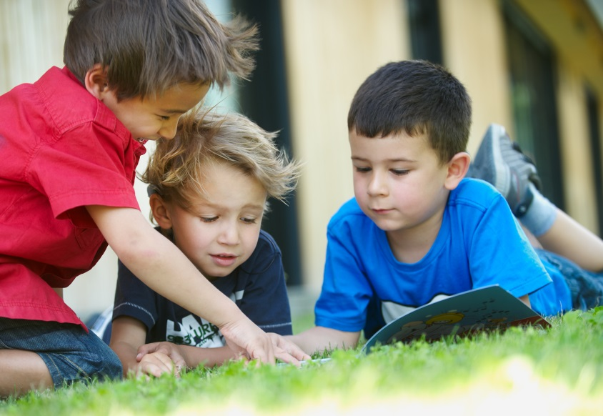
By Donna Sperandio
Posted 10.04.2015

Theory of Mind. It’s all about the mind—how someone thinks and responds to other people’s thoughts. Everybody’s mind develops naturally through their childhood, and if your child has a hearing loss there are some special considerations to help them develop their best.

It’s The Basis of All Social Interaction

The Theory of Mind is the idea that each child develops an understanding of their own thoughts, desires, and beliefs—and can recognize that other people have their own thoughts, desires, and beliefs. Ever hear the phrase “to put yourself in their shoes”? That’s the Theory of Mind in action.

Basically, it’s everything to do with thinking about thinking.

There are lots of different skills that a person develops through their Theory of Mind. These skills are really helpful:

- At the most basic level, they help us to see other people’s points of view, motives, wants, thoughts, and beliefs—and express our own. Ideas like “I like apples”, “I don’t like carrots”, ”I hope I get a doll for my birthday”, “I think he went outside”, and “I thought I left my keys on the table, so I came back to check” are all examples of these thoughts.
- They help children develop both socially and emotionally. Having an understanding of their mind and others’ minds plays a significant role in building peer relationships and succeeding in school.
- They help everybody to communicate effectively with skills like empathy, persuasion, inference, reasoning, thinking critically, cooperation, and understanding narratives and texts.
- They make conversations easier by allowing someone to predict what the listener already knows, what they might need to know, how they’re reacting, and what should be said next.

Developing the Theory of Mind’s Skills

These skills can be seen just about everywhere from daily life to social interaction. Because of this they’re often not directly taught. Instead, they’re learned incidentally and develop early in childhood: naturally and often in tandem with language development.

The words we learn are used to express our thoughts and beliefs, and these thoughts and beliefs are understood through the Theory of Mind’s skills. For example, verbs about different thoughts, like ‘think’, ‘believe’, ‘remember’, ‘know’, ‘wish’, ‘like’, ‘imagine’, ‘guess’, ‘understand’ are abstract concepts—they aren’t something that we can always observe or see. Because of this they often aren’t directly taught, and instead are learned by overhearing others use them over and over in different contexts and conversations.

For Your Child with a Hearing Loss

This is why it’s so important your child is given lots of access to language and speech early in their life. Exposure to rich and meaningful language, and a wide range of opportunities to hear this language across varying contexts, is the best way for someone to develop their own understanding and use of this language. And again, it’s access to this language, and opportunities to practice using it, that helps build these important Theory of Mind skills.

If a child has less exposure to situations where Theory of Mind concepts are used, then their development of these skills might be impacted. And for your child with hearing loss, exposure alone might not be enough. If they are in a situation where people are talking about Theory of Mind concepts—like empathy, inference, and critical thinking—but your child can’t understand the conversation, then they might not get the most out of the situation.

What can you do to make sure your child gets the most out of each situation? Here are some ways to get the most out of the everyday interactions that help to shape theory of mind skills:

- Make sure your child has optimal access to sounds at conversational volume during all waking hours.
- Reduce background noise by turning off unused sound sources like TVs or radios, allowing your child to better hear spoken conversations around them.
- Ensure your child is close to the person he or she is listening to.
- Allow and encourage your child to have opportunities to observe and overhear conversations that don’t directly involve them: for example, conversations that siblings might be having at home when playing and negotiating during a game; conversations that members of the community might have, like talking about where they would like to go on holidays, or what they would like to buy; or friends telling stories and jokes to each other.
- Narrate your own thoughts and feelings, incorporating mental or thinking verbs such as ‘think’, ‘know’, ‘like’, ‘remember’, ‘believe’, ‘wish’, ‘forget’, ‘guess’. Talk about people’s interactions to your child, and predict what they might be saying, thinking or feeling—and why they might have these thoughts and feelings. Highlight to your child that our feelings and thoughts can differ from another person’s.
- Make sure your child has a range of opportunities to hear and use these concepts in their own interactions and play, because your child will better understand the meaning of these concepts through repeated and rich exposure and practice.

